OS Assignment-01 part-b

By-Jeetu Mehra
U24AI032

Question 1 : Write a program to create an empty file named notes.txt inside the Assignment1 directory. Add the text "UNIX is fun!" to the file notes.txt using a single command.
Output:
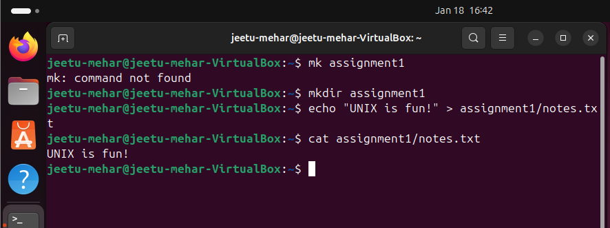

Question 2 : Display the content of notes.txt on the terminal. Count the number of lines, words, and characters in notes.txt.
Output:
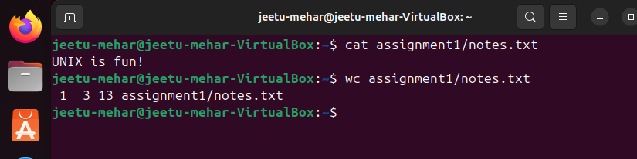

Question 3 : Create a directory named ProjectWorkspace. Inside ProjectWorkspace, create subdirectories Docs, Code, and Resources. In the Docs directory, create an empty file named README.txt. Move into the Code directory and create an empty file main.py.
List all files and directories in ProjectWorkspace to verify the setup.
Output:
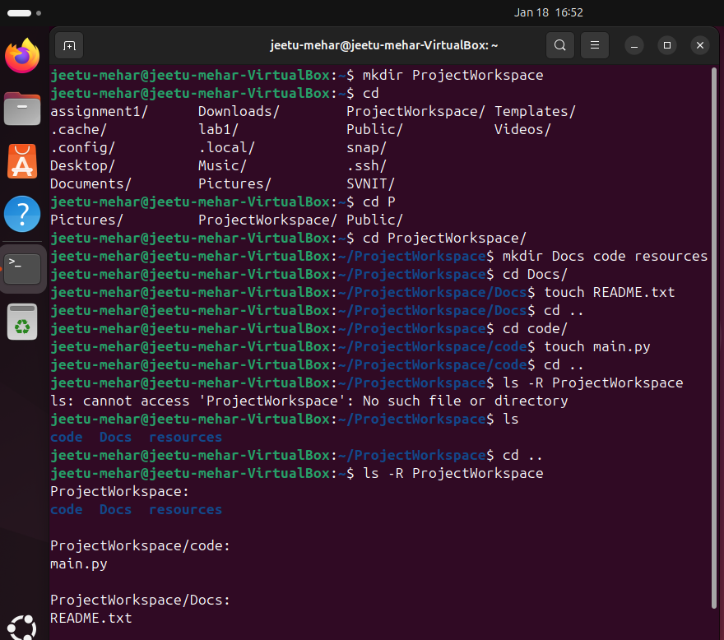

Question 4 : In the current directory, create files old_report1.txt, old_report2.txt, and current_report.txt. Move all files starting with "old_" into a directory named OldReports. Verify the moved files by listing the content of OldReports.
Output:
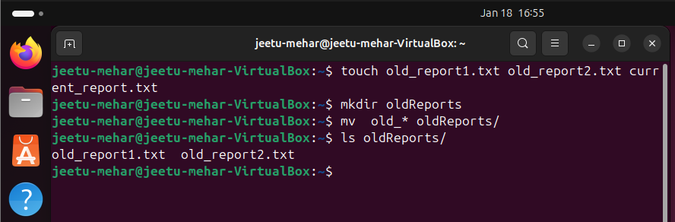

Question 5: Write a Shell Script for counting the lines in the text file.
Output:
